Oracle API Platform Virtual Workshop Labs

Contents

• Introduction 2

1. API Platform (API-Design) 2

2. API Platform (API Exposure) 9

2.1. Create the Link to Apiary 10

2.2. Change API Request Policy 13

2.3. Deploy the API to a Gateway 14

2.4. Activate API Plan 16

2.5. Test the API in Postman 16

2.6. Add a Policy 19

2.7. Publish to the Developer Portal 22

2.8. Check out the API in the Developer Portal 25

2.9. Apply a Security Policy 28

# Introduction

This set of labs covers the following Oracle Services –

* Apiary – for API Design
* API Platform CS – for API Management
* **Bullets** will mark **actions**

The use case is very simple – we need to be able to expose an API that allows us to create new organizations, we will start from the design of that API in the first part and in second part look into management of that API on exposure side.

# API Platform (API-Design)

Apiary is the de facto tool for designing APIs. At this stage you should have been given access to Apiary.

* Login to Apiary at <http://apiary.io>
  + Your trainer will provide you with the credentials
* Create a new API Project

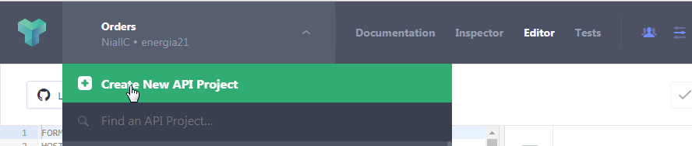

* Enter the name – **NN**-OrganizationService

**NN** being the number assigned to you by the trainers

* + Make sure to select **Team API**.
  + Keep the format as **API Blueprint**.

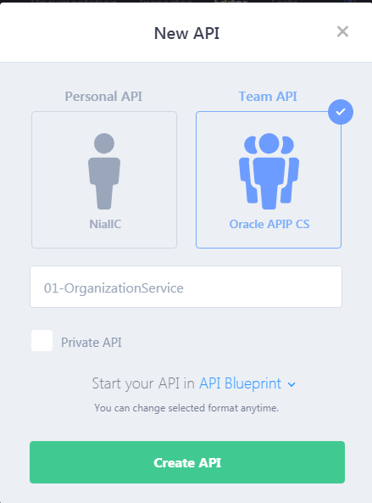

Your API project is created with default content – this default API is with Polls example –

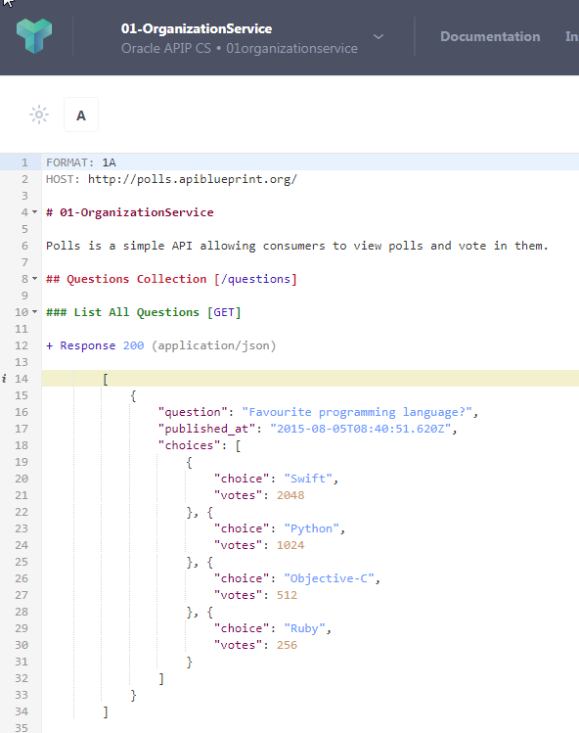

* Copy and paste the definition below, replacing the example API with API that describes service that is supposed to create organization .

|  |
| --- |
| FORMAT: 1A  HOST: http://organizations.apiblueprint.org/  # OrganizationService  OrganizationService is an API for managing your Service Cloud Organizations  ## Organizations Collection [/organization]  ### Create an Organization [POST]  + Request (application/json)  {  "orgName": "The Hare of the Dog Public House",  "contactFirstName": "Chris",  "contactLastName": "O'Connor",  "contactEmail": "cc@hotd.ie",  "country": "IE"  }  + Response 201 (application/json)  + Headers  Location: /organization/2  + Body  {  "orgId": "123",  "status": "New Org Created"  } |

You should now have an API definition which looks like this:

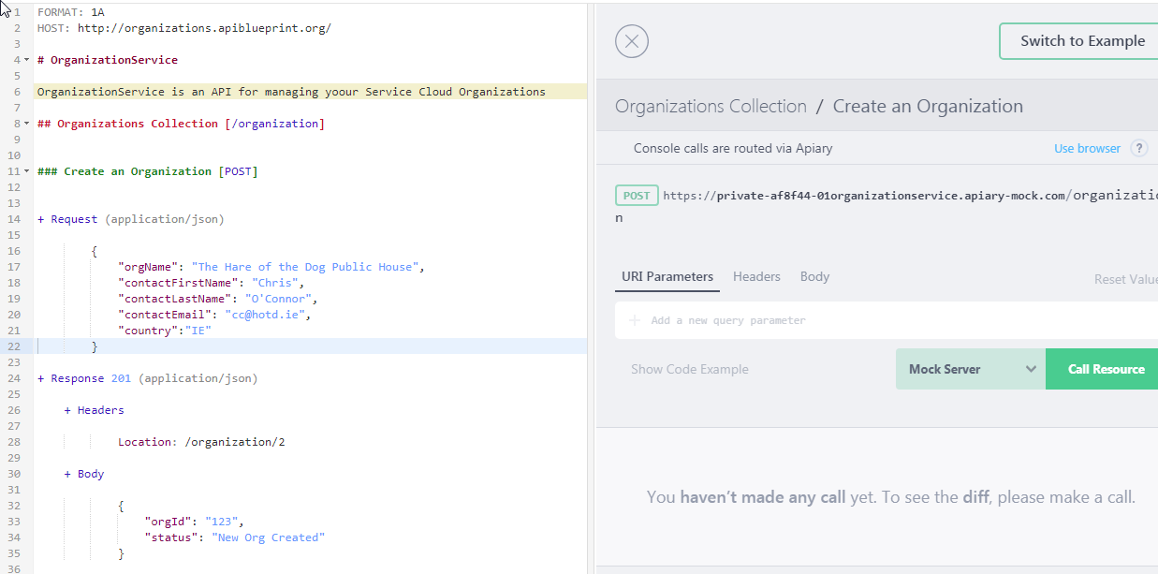

* Click **Save**

Note the 2 panels – the definition on the left in API Blueprint – the more documentary version on the right.

* Click on **“Create an Organization”** in the right panel.

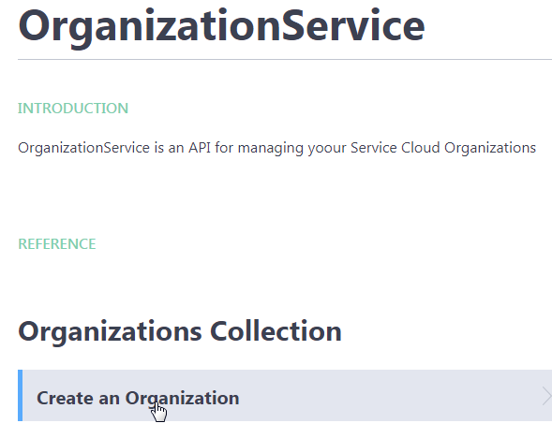

Apiary comes with its own “mock” server, which “hosts” the APIs. This allows us to test the API.

* Note the URL at the top – should look something like this:

|  |
| --- |
| https://private-af8f44-01organizationservice.apiary-mock.com/organization |

Also note the multi-programming language support.

* Next to Mock Server - Select **cURL** and click **Try**.   
  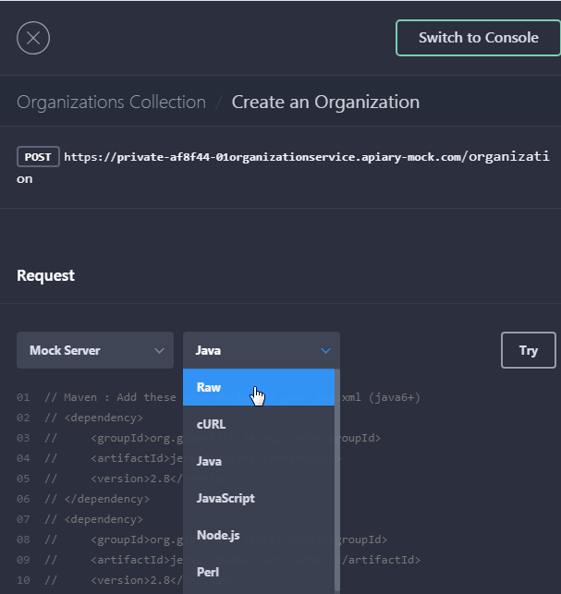
* Click **Call Resource**

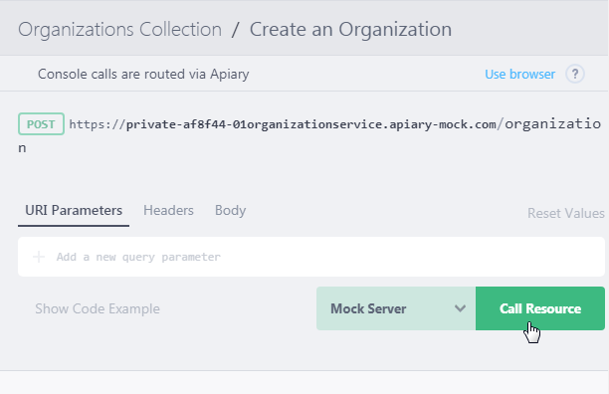

This should prompt a response like this:

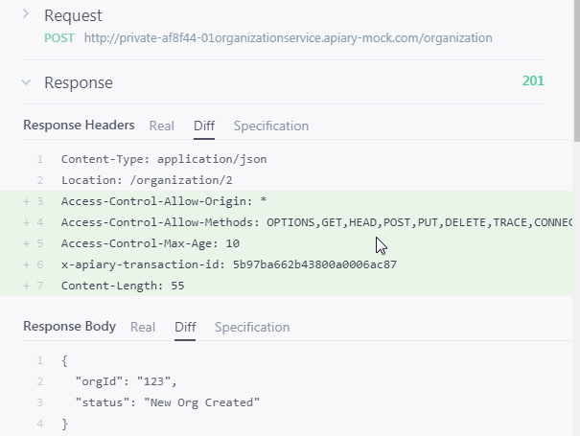

So now we have our API contract, we also have a stub that a mobile developer could use to start developing a mobile app, while we now look at implementing this API in OIC.

# API Platform

* Login to **API Platform – Management Portal**
  + Use your trial account
* **Click on APIs tab on the top left corner**

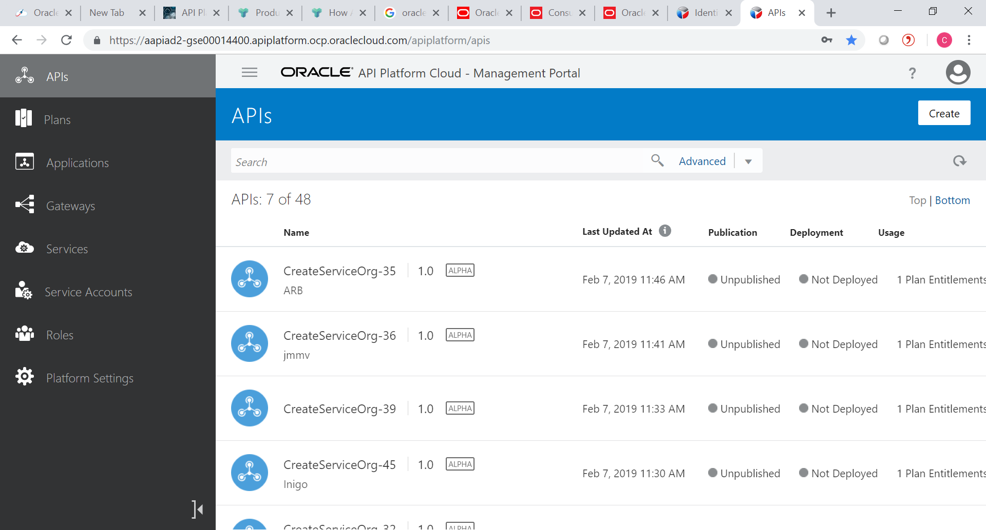

* Click on Create API on the top right corner



* Enter CreateServiceOrg-**NN** as API name and 1.0 as version. Select ‘Create a default plan for this API’

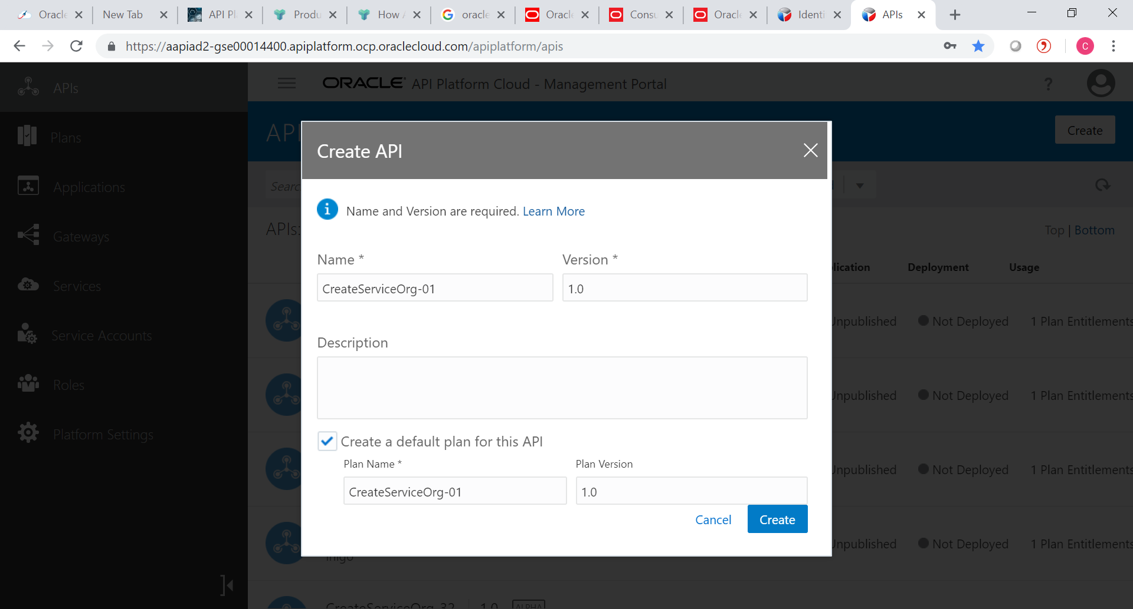

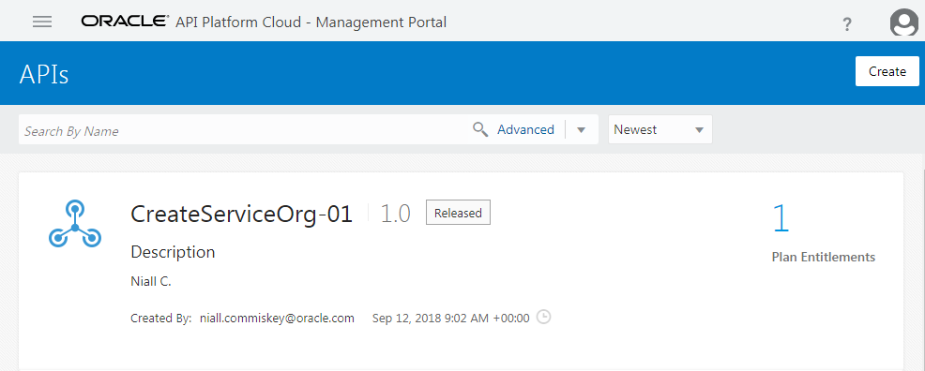

**Note** a Plan has also been created. APIs are made available to developers through Plans.

## Change API Request Policy

* If not open already, open your API
* Click **API Implementation**
* Click **API Request** Policy
* Click **Edit**

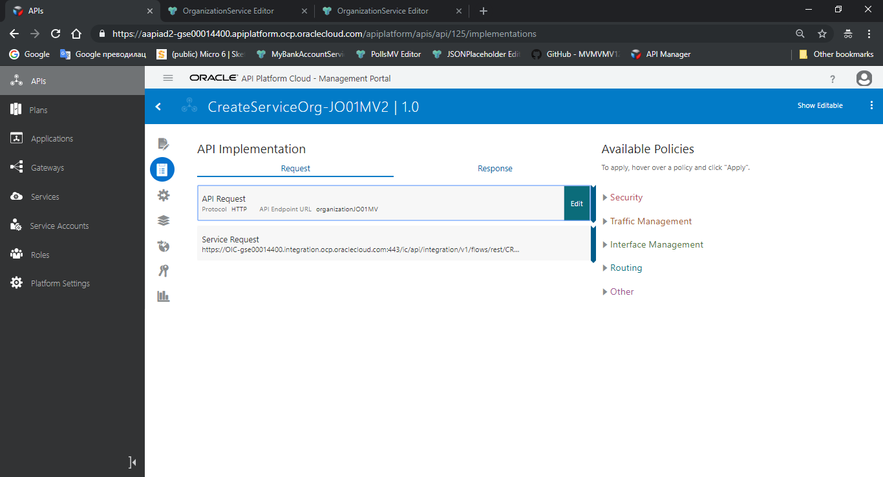

* Under **API Request URL** enter **OrganizationNN**
* Click **Apply**

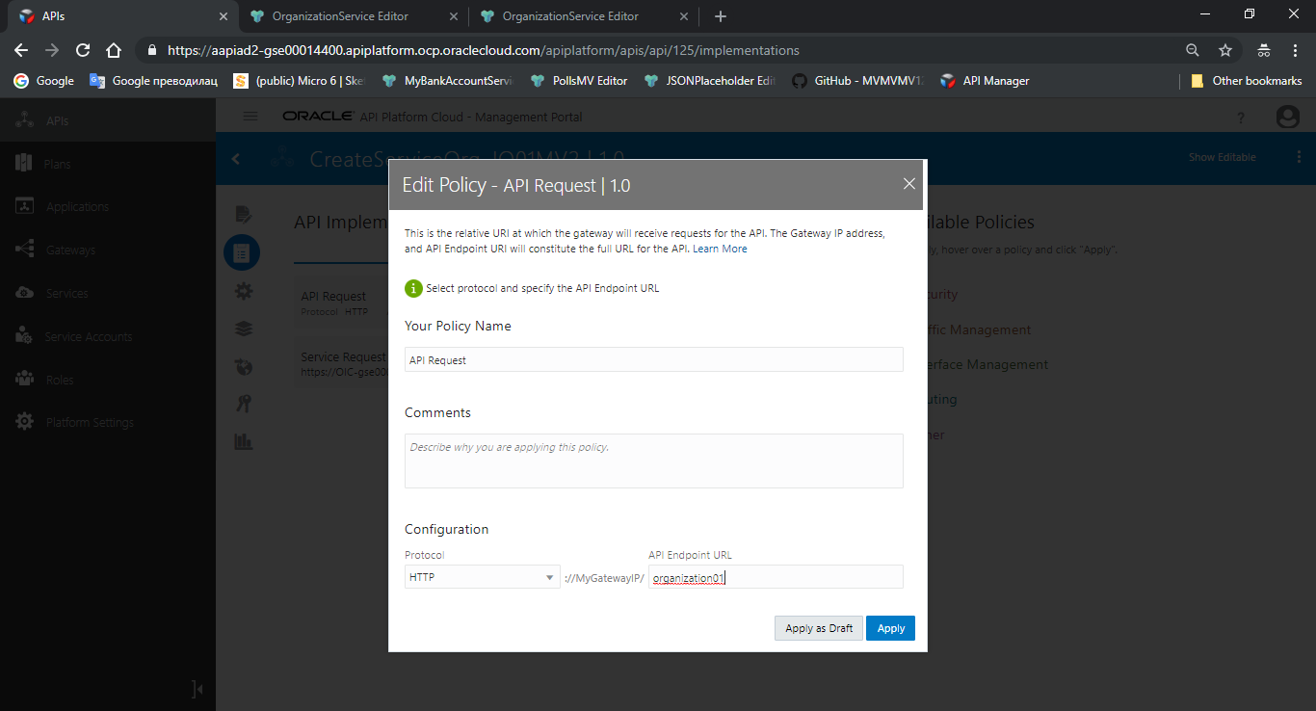

## Deploy the API to a Gateway

Now we will deploy the API to a **Gateway**. These can run anywhere – on-premise, in the Oracle cloud, in any other cloud.

* Click on **Deployments**

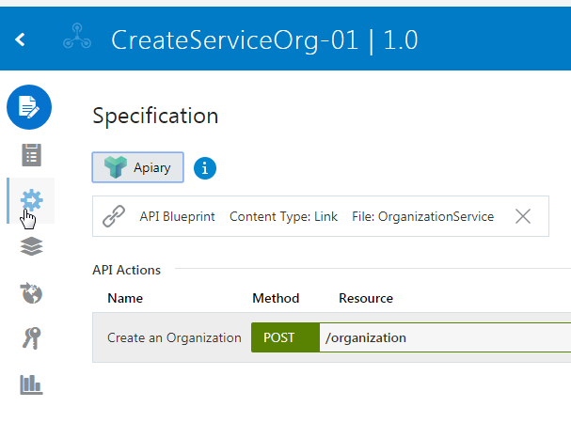

* Click **Deploy API**

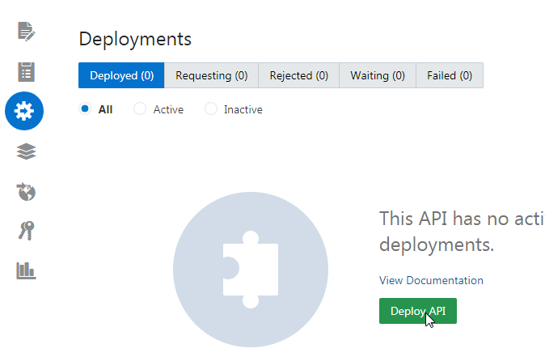

* **Configure** as follows
  + Development Gateway is checked
  + Initial Deployment State: Active
* Click **Deploy**

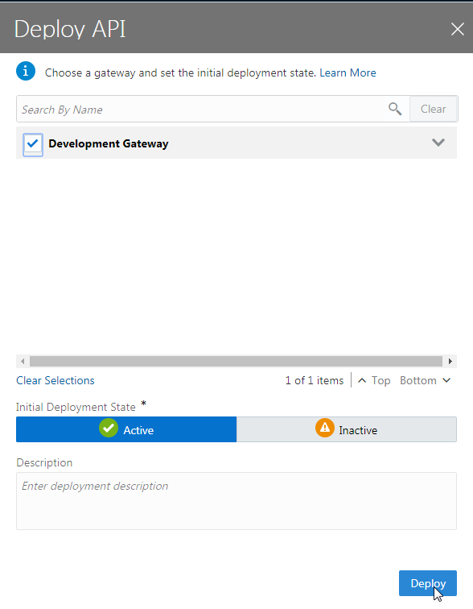

**Note** that the number of API’s waiting (n) for deployment is incremented before the number of Deployed (n) is incremented.

* **Verify** that new Gateway was deployed

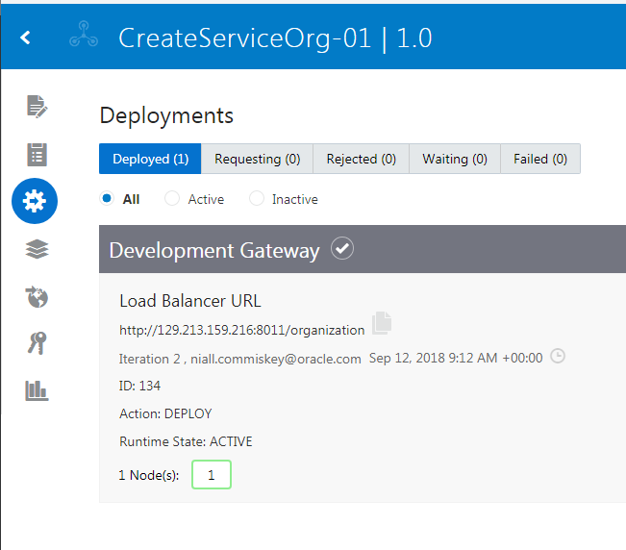

## Activate API Plan

* From the left-hand main menu - Click on **Plans**
* Select **your API-Plan** and open it
* From the more-menu in the upper-right corner
  + Change the status to **Active**
  + When prompted if you are sure, click **Yes**

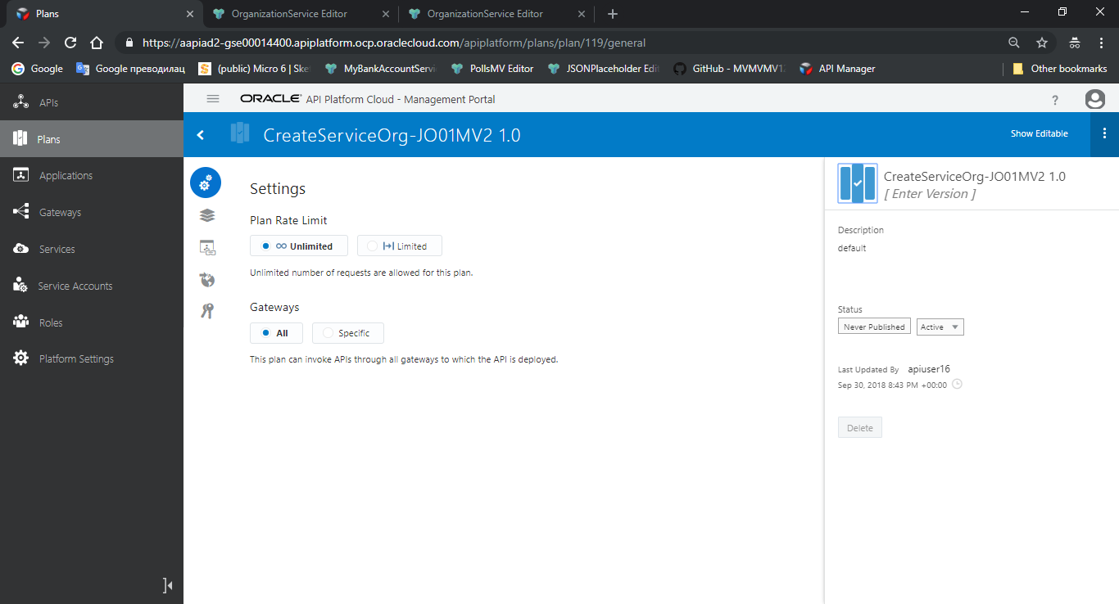

## Test the API in Postman

Now let’s test the API – using Postman (or similar program)

* Navigate back to your API. Remember the newly deployed gateway. **Copy** the associated **URL**



* In Postman, open a new Request-tab
  + Enter the **URL** you copied
  + Add “*/createOrg*” to the **end of the URL** (remember the API-design)
  + Make sure you are using a **POST**-call
  + Under the tab **Authorization**
    - Type: Basic Auth
    - Enter your OIC credentials

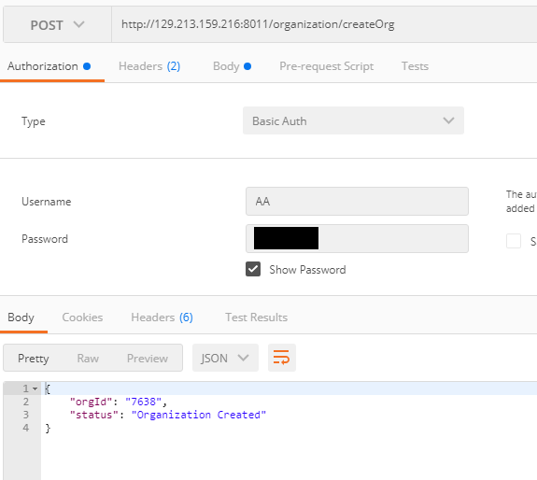

* Click on the **Body**-tab
  + Choose **“raw”s**
  + Select **“JSON(application/json)”**
* Enter the **request payload**

|  |
| --- |
| { "orgName": "The Hare of the Dog Public House", "contactFirstName": "Chris", "contactLastName": "O'Connor", "contactEmail": "cc@hotd.ie", "country":"IE" } |

* Click **Send**

You should have the following response:



## Add a Policy

Now you will add the a policy to regulate Traffic in the API.

* Open **your API**
* Select **API Implementation**
* From the list on the right-hand side “Available Policies”, **expand** Traffic Management
* Click **Apply** on *“API Rate Limiting”*

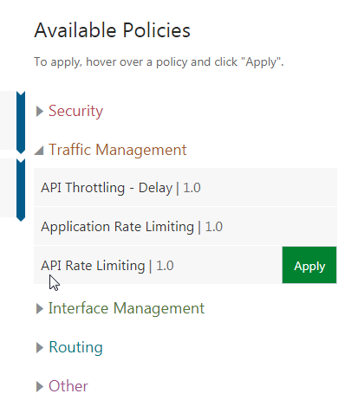

* **Configure** as follows
  + Policy name: Leave as-is (*API Rate Limiting*)
  + Place after the following policy: As-is (*API-Request*)
  + **Click next** ( “>”-icon )
  + Allow API Rate Limiting: **per Logical Gateway**
  + API Rate Limit: **4**
  + Time Interval: **Minute**
* Click **Apply**

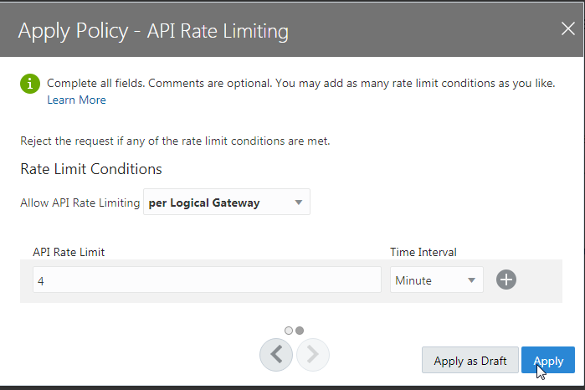

* Click **Save**

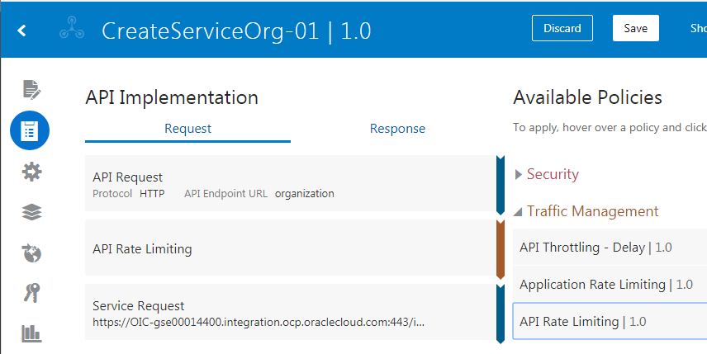

* **Re-deploy** to the Gateway

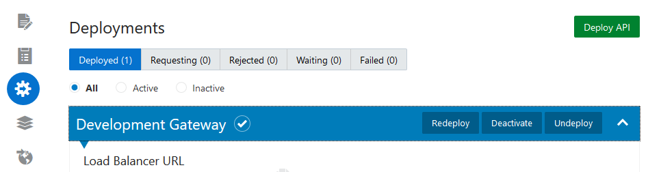

* Test in Postman
  + The 5th request will elicit the following response

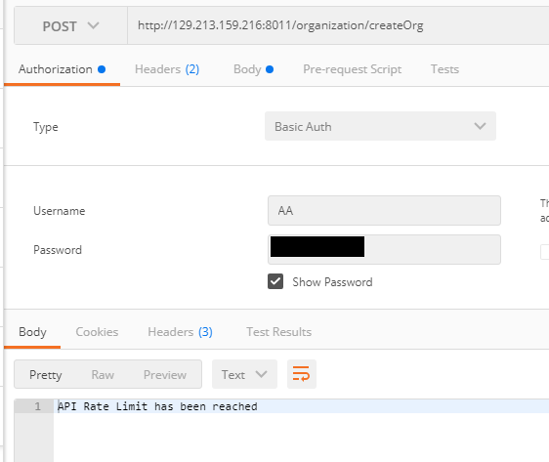

## Publish to the Developer Portal

Before we publish, let’s look at your Plan (CreateServiceOrg-**NN**)

* **Open** your Plan

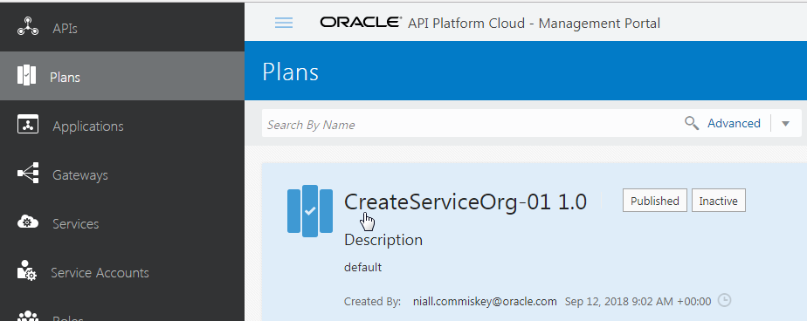

The API is listed in the plan, but needs to be published to be activated

* Click **Entitlements**
* **Hover** over **Unpublished** to make the choices visible
* Click **Publish**
* When prompted **“Are you sure you want to publish this entitlement?”** – click **Yes**

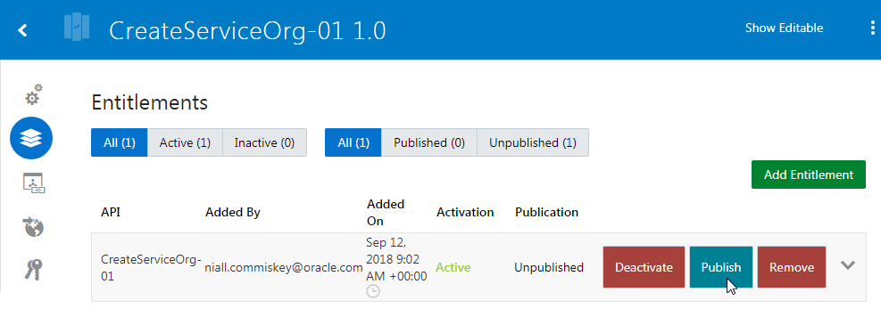

You can verify the results:

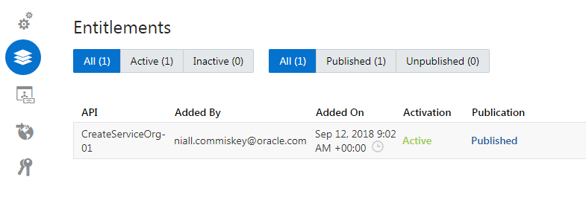

Now we can publish the plan to the developer portal

* Click on **Publication**
* View the URL and ending, its own unique **Vanity Name**. A vanity name is the URI path of an API’s details page when it is published to the Developer Portal.

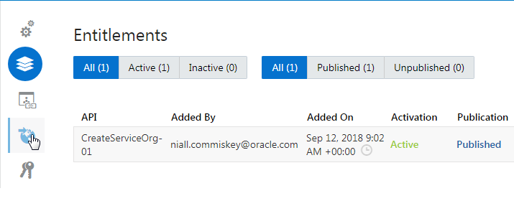

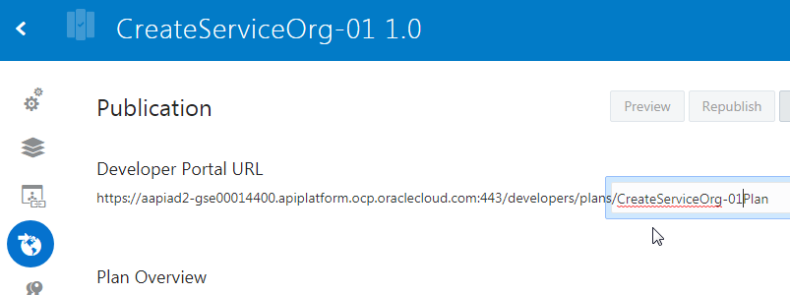

Once Published, you can unpublish, republish etc.

Let’s now deploy the API to the Developer Portal

* Once back in **your API**, CreateServiceOrg-**NN**, and click on **Publication**
* **Click** on the end of the API Portal URL to edit the unique name
* Click the **check-mark** to verify

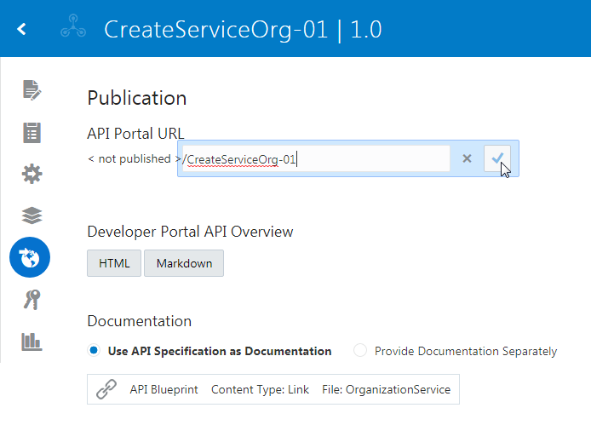

* Click **Publish to Portal**

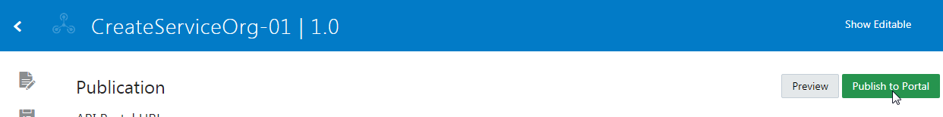

## Check out the API in the Developer Portal

* Login to the **API Platform -** **Developer Portal**
  + Use your cloud trial account
* Identify **your API** in the list, filter by searching if needed
* **Click** on it

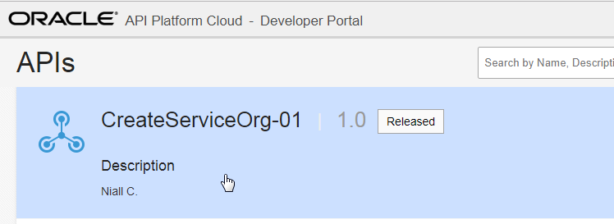

Note the embedded documentation from Apiary (only if Standard or Professional edition of Apiary is used).

* Click on **Subscribe**

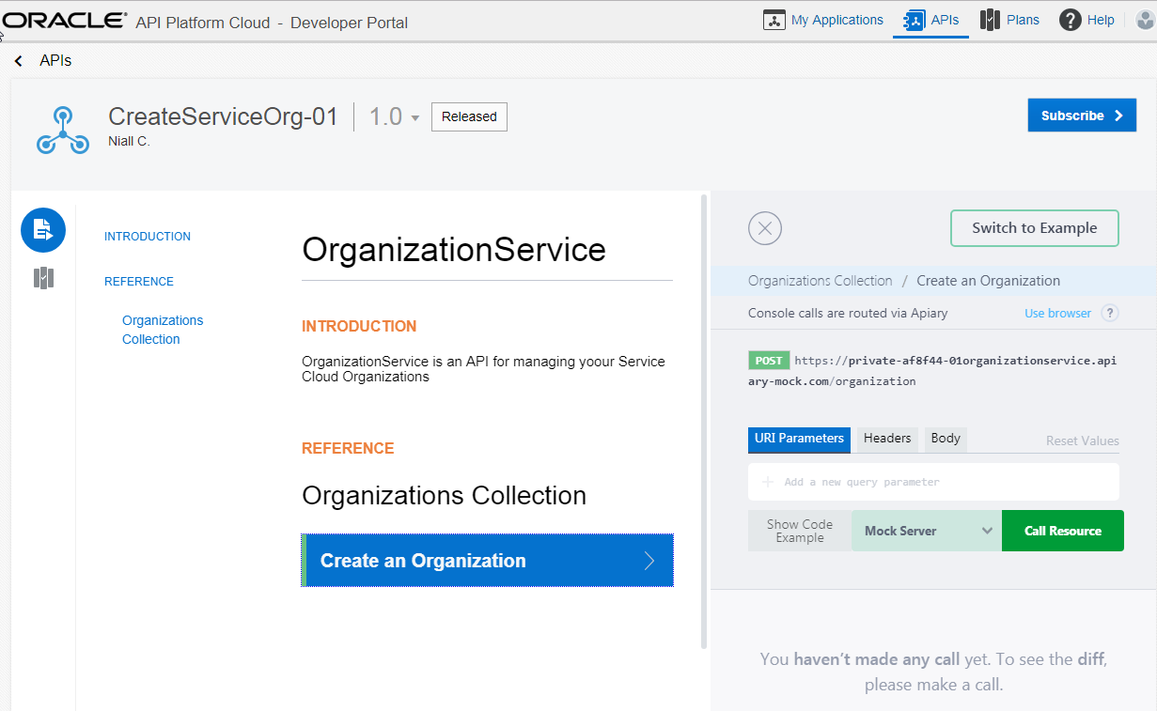

* Click on **Select Plan**

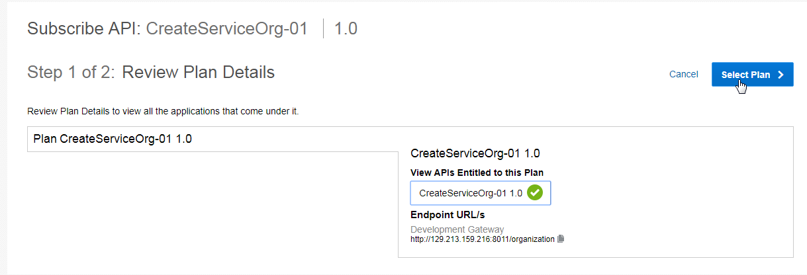

APIs are used in the context of an Application, e.g. a mobile app the developer is working on.

* Click **Create New Application**

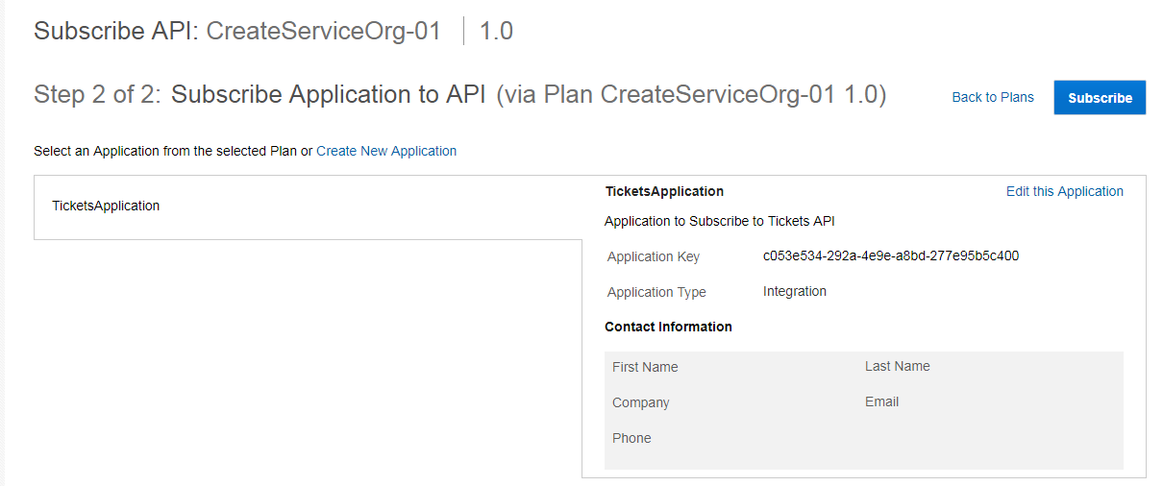

* **Enter** your app name etc.
* Click **Save**

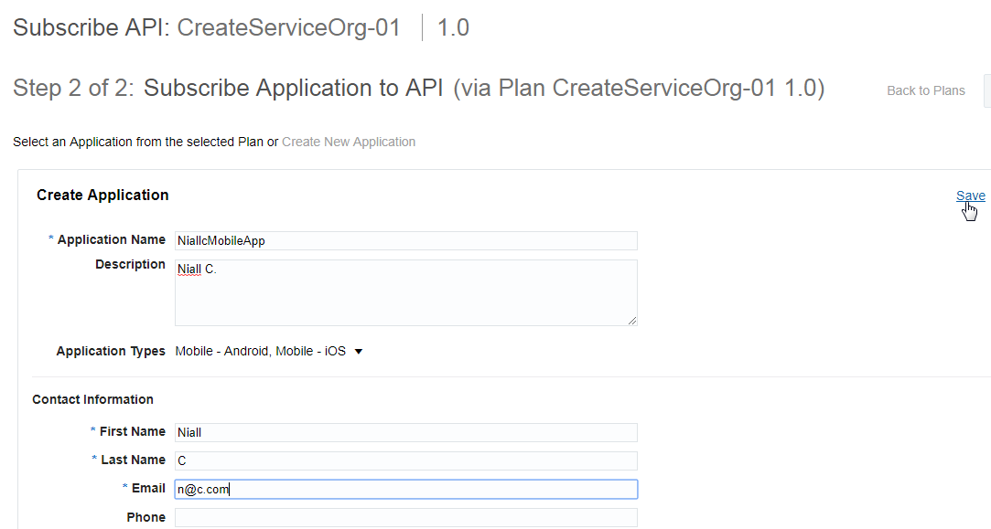

* Note the **Application Key**, **copy** it for later
* Click **Subscribe**

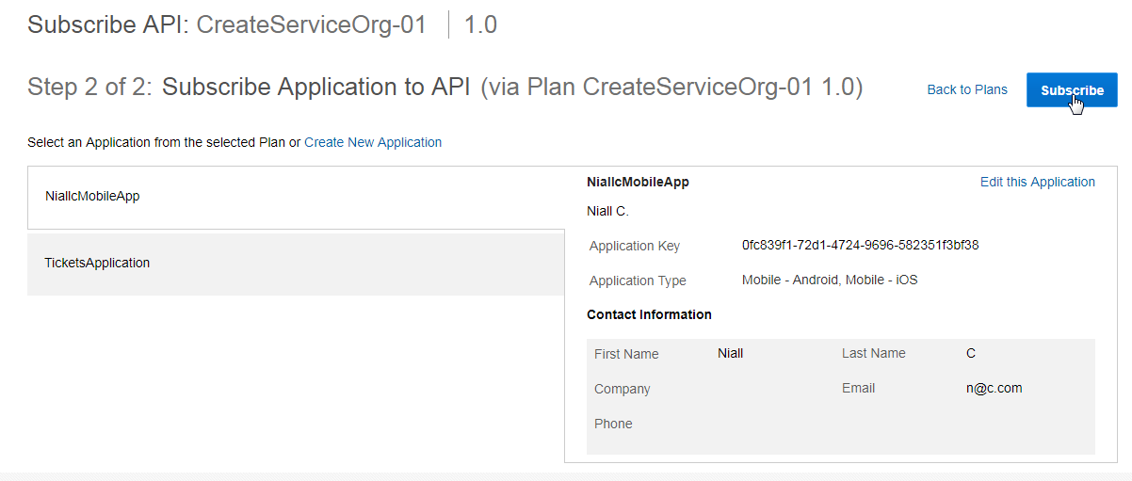

* Verify subscription was successful

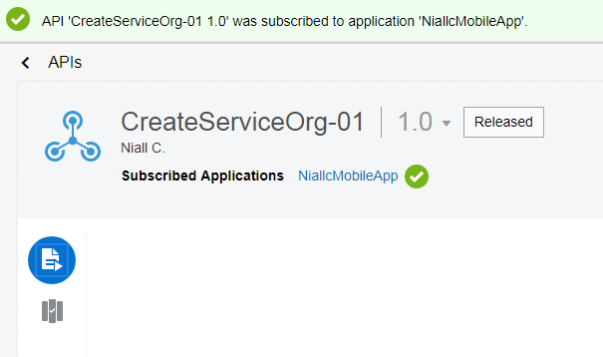

## Apply a Security Policy

* Navigate back to the **API Platform – Management Portal**
* Open **your API**, CreateServiceOrg-**NN**
* Click on **API Implementation**
* From the list on the right with **Available Policies**
  + Under Security, select **Key Validation**

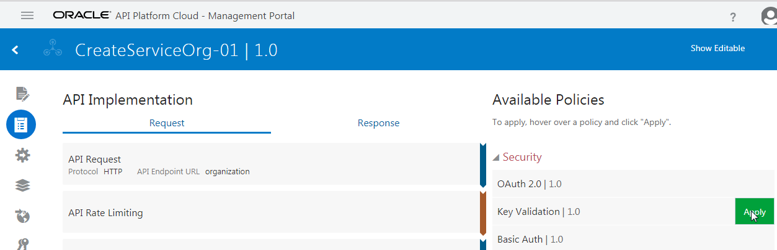

* **Configure** as follows
  + Leave first page as-is, click the “>”-icon¨
  + Select **Header**
  + Key Header: **app-key**
  + Click **Apply**

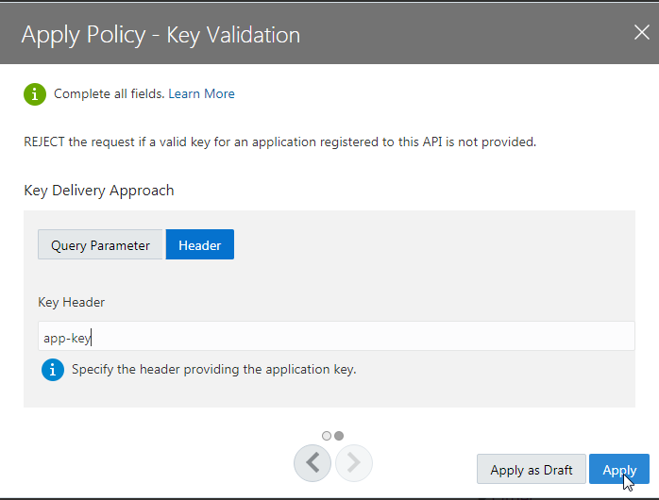

* Click **Save**
* Click on **Deployments**
* **Re-deploy** the API to the Gateway
* Open **Postman**
  + **Test** the POST-request again
* Note the Response

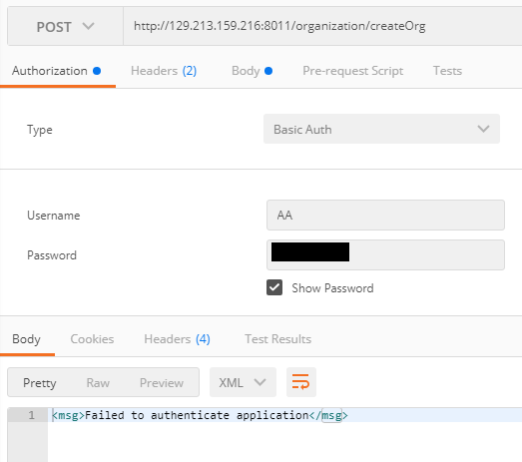

* **Add the key** to the request
  + In the request “Headers”
  + Add key: **app-key**
  + In the Value-section, paste your **Application Key**
* **Test** again